HISTORY of REVISION
Rev.  No. | Effective Date | Revised Page (s) | Description | Prepared by | Checked  by | Noted  by | Approved by
01 |  |  | New | ANJK | DJN HM | ON | FM
02 |  | 4 - 6  6,7  9 | Update H2S Gas detector PVHI values from 4 ppm to 5 ppm  Added instruments – 106AI013AB, 106AI005AB and 106AI002  Update DCS Graphics for MS Environment | DJN | TY | ME | MK
Prepared by | Checked by | Noted by | Approved by
Dexter J. Navales | Tomoaki Yoneyama | Manabu Enomoto | Munekazu Kawata
Date: | Date: | Date: | Date:
IMPORTANT:
THIS COVER SHEET FORM IS PART OF THE FOLLOWING DOC SHEETS AND IS NOT TO BE DISCARDED UNLESS SUPERCEDE BY A REVISED ISSUE. UNAUTHORIZED REPRODUCTION IS STRICTLY PROHIBITED.

CONTENTS
I. General Description 3
II. Controllers’ Description and Instruments Function 4
1. Controllers’ Description 4
2. Instruments’ Description 4
1) “(1) (105AI904)”: H2S Gas Detector at 105TK01 Area 4
2) “(2) (105AI901)”: H2S Gas Detector at 105TK03 Area 4
3) “(3) (105AI902)”: H2S Gas Detector at 105PU01C Area 4
4) “(4) (106AI910)”: H2S Gas Detector at MS Reactor Area – Northeast Side 4
5) “(5) (106AI912)”: H2S Gas Detector at 106VE01 Sampling Area 4
6) “(6) (106AI909)”: H2S Gas Detector at 106VE02 Sampling Area 4
7) “(7) (106AI908)”: H2S Gas Detector at 106VE03 Sampling Area 5
8) “(8) (106AI907)”: H2S Gas Detector at 106VE04 Sampling Area 5
9) “(9) (106AI906)”: H2S Gas Detector at 106CP01AB Area 5
10) “(10) (106AI905)”: H2S Gas Detector at 106VB01AB Area 5
11) “(11) (106AI915)”: H2S Gas Detector at 106TH01 Area 5
12) “(12) (106AI904)”: H2S Gas Detector at 106SR02 Area 5
13) “(13) (106AI903)”: H2S Gas Detector at 106FN01AB Area 5
14) “(14) (106AI902)”: H2S Gas Detector at 106TK04 Area 6
15) “(15) (106AI901)”: H2S Gas Detector at 106TK18 Area 6
16) “(16) (106AI911)”: H2S Gas Detector at 106TK09A Area 6
17) “(17) (105AI906)”: H2S Gas Detector at 105TK13 Area 6
18) “(18) (106AI013A)”: H2S Gas Analyzer A for 106SR03 6
19) “(19) (106AI013B)”: H2S Gas Analyzer B for 106SR03 6
20) “(20) (106AI005A)”: H2S Gas Analyzer A for 106SR02 6
21) “(21) (106AI005B)”: H2S Gas Analyzer B for 106SR02 7
22) “(1) (106AI002)”: O2 Gas Analyzer for 106SR02 7
3. Motors 7
4. Actuated Valves 7
5. Switches 7
1) 000HS901: DCS Common Acknowledge Switch 7
2) 000HS902: DCS Common Reset Switch 7
III. Important Monitoring Items 8
IV. Interlocks 8
V. Control Sequences 8
VI. Alarms 8
VII. DCS Emergency Shutdown 8
VIII. Troubleshooting Guide 8
IX. Trend Graphs Grouping 8
Annex 1: MS ENVIRONMENT DCS Graphics 9

General Description

This graphics contains the schematic diagram of the MS/De-Zn area plot plan wherein the graphical locations of the H2S gas detectors are reflected in the graphics. The actual measured values of these environment monitoring instruments are also displayed in this screen.

The H2S gas detectors are equipped with process alarms that are triggered once PVHI value is reached. When these alarms are triggered, the text color of the measured value will change into RED, the instrument graphics will light up and blink, and, audible alarm in DCS will sound in order to alert the DCS operator. Additionally beacon and horn system are activated in the field to warn the field operators there is possible gas leak in their area.

Acknowledge and Reset buttons for the alarms are also provided in this graphics. The common acknowledge (ACK) button (000HS901) is used by the DCS operator to acknowledge the alarm and silence the audible alarms/horns in the DCS room and in the field. However, the alarm beacon shall remain lighted until the alarm has been reset by common reset (RESET) button (000HS902). The RESET button will only function when the normal parameter value has been restored.

Shortcut link buttons for the Graphics Overview, Environment Monitoring and H₂S Environment are also present in this screen. These shortcut link buttons are used to jumped from the present MS Environment Monitoring screen to the above mentioned DCS graphics screens.

Controllers’ Description and Instruments Function

Controllers’ Description

None

Instruments’ Description

“(1) (105AI904)”: H2S Gas Detector at 105TK01 Area

This H2S gas detector measures H2S gas concentration of ambient air around 105TK01 area. This gas detector is connected to De-Zn common beacon (105XA921) and horn (105XA922) system that is located in the common pipe rack which is in the northeast-side of 105TK01.
(Operating Range: PVHI: 5 ppm; PVHH: 10 ppm)

“(2) (105AI901)”: H2S Gas Detector at 105TK03 Area

This H2S gas detector measures H2S gas concentration of ambient air around 105TK03 area. This gas detector is connected to De-Zn common beacon (105XA921) and horn (105XA922) system that is located in the common pipe rack which is in the northeast-side of 105TK01.
(Operating Range: PVHI: 5 ppm; PVHH: 10 ppm)

“(3) (105AI902)”: H2S Gas Detector at 105PU01C Area

This H2S gas detector measures H2S gas concentration of ambient air around 105PU01C area. This gas detector is connected to De-Zn common beacon (105XA921) and horn (105XA922) system that is located in the common pipe rack which is in the northeast-side of 105TK01.
(Operating Range: PVHI: 5 ppm; PVHH: 10 ppm)

“(4) (106AI910)”: H2S Gas Detector at MS Reactor Area – Northeast Side

This H2S gas detector measures H2S gas concentration of ambient air around MS Rector Feed Area. This gas detector is connected to common beacon (106XA923) and horn (106XA924) system that is located in the common pipe rack which is in the north-side of MS Filter Building.
(Operating Range: PVHI: 5 ppm; PVHH: 10 ppm)

“(5) (106AI912)”: H2S Gas Detector at 106VE01 Sampling Area

This H2S gas detector measures H2S gas concentration of ambient air around 106VE01 area. This gas detector is connected to common beacon (106XA923) and horn (106XA924) system that is located in the common pipe rack which is in the north-side of MS Filter Building.
(Operating Range: PVHI: 5 ppm; PVHH: 10 ppm)

“(6) (106AI909)”: H2S Gas Detector at 106VE02 Sampling Area

This H2S gas detector measures H2S gas concentration of ambient air around 106VE02 area. This gas detector is connected to common beacon (106XA923) and horn (106XA924) system that is located in the common pipe rack which is in the north-side of MS Filter Building.
(Operating Range: PVHI: 5 ppm; PVHH: 10 ppm)

“(7) (106AI908)”: H2S Gas Detector at 106VE03 Sampling Area

This H2S gas detector measures H2S gas concentration of ambient air around 106VE03 area. This gas detector is connected to common beacon (106XA923) and horn (106XA924) system that is located in the common pipe rack which is in the north-side of MS Filter Building.
(Operating Range: PVHI: 5 ppm; PVHH: 10 ppm)

“(8) (106AI907)”: H2S Gas Detector at 106VE04 Sampling Area

This H2S gas detector measures H2S gas concentration of ambient air around 106VE04 area. This gas detector is connected to common beacon (106XA923) and horn (106XA924) system that is located in the common pipe rack which is in the north-side of MS Filter Building.
(Operating Range: PVHI: 5 ppm; PVHH: 10 ppm)

“(9) (106AI906)”: H2S Gas Detector at 106CP01AB Area

This H2S gas detector measures H2S gas concentration of ambient air around 106CP01AB area. This gas detector is connected to common beacon (106XA923) and horn (106XA924) system that is located in the common pipe rack which is in the north-side of MS Filter Building.
(Operating Range: PVHI: 5 ppm; PVHH: 10 ppm)

“(10) (106AI905)”: H2S Gas Detector at 106VB01AB Area

This H2S gas detector measures H2S gas concentration of ambient air around 106VB01AB area. This gas detector is connected to common beacon (106XA923) and horn (106XA924) system that is located in the common pipe rack which is in the north-side of MS Filter Building.
(Operating Range: PVHI: 5 ppm; PVHH: 10 ppm)

“(11) (106AI915)”: H2S Gas Detector at 106TH01 Area

This H2S gas detector measures H2S gas concentration of ambient air around 106TH01 area. This gas detector is connected to common beacon (106XA921) and horn (106XA922) system that is located in the common pipe rack which is in the northwest-side of 106SR03.
(Operating Range: PVHI: 5 ppm; PVHH: 10 ppm)

“(12) (106AI904)”: H2S Gas Detector at 106SR02 Area

This H2S gas detector measures H2S gas concentration of ambient air around 106SR02 area. This gas detector is connected to common beacon (106XA921) and horn (106XA922) system that is located in the common pipe rack which is in the northwest-side of 106SR03.
(Operating Range: PVHI: 5 ppm; PVHH: 10 ppm)

“(13) (106AI903)”: H2S Gas Detector at 106FN01AB Area

This H2S gas detector measures H2S gas concentration of ambient air around 106FN01AB area. This gas detector is connected to common beacon (106XA921) and horn (106XA922) system that is located in the common pipe rack which is in the northwest-side of 106SR03.
(Operating Range: PVHI: 5 ppm; PVHH: 10 ppm)

“(14) (106AI902)”: H2S Gas Detector at 106TK04 Area

This H2S gas detector measures H2S gas concentration of ambient air around 106TK04 area. This gas detector is connected to common beacon (106XA921) and horn (106XA922) system that is located in the common pipe rack which is in the northwest-side of 106SR03.
(Operating Range: PVHI: 5 ppm; PVHH: 10 ppm)

“(15) (106AI901)”: H2S Gas Detector at 106TK18 Area

This H2S gas detector measures H2S gas concentration of ambient air around 106TK18 area. This gas detector is connected to common beacon (106XA921) and horn (106XA922) system that is located in the common pipe rack which is in the northwest-side of 106SR03.
(Operating Range: PVHI: 5 ppm; PVHH: 10 ppm)

“(16) (106AI911)”: H2S Gas Detector at 106TK09A Area

This H2S gas detector measures H2S gas concentration of ambient air around 106TK09A area. This gas detector is connected to two beacon and horn systems located inside the MS Filter Building. The beacon – 106XA927 and horn – 106XA928 system is located in the west-side entrance of the MS Filter Building. The beacon – 106XA925 and horn – 106XA926 system is located in the east-side entrance of the MS Filter Building.
(Operating Range: PVHI: 5 ppm; PVHH: 10 ppm)

“(17) (105AI906)”: H2S Gas Detector at 105TK13 Area

This H2S gas detector measures H2S gas concentration of ambient air around 105TK13 area. This gas detector is connected to two beacon and horn systems located inside the MS Filter Building. The beacon – 106XA927 and horn – 106XA928 system is located in the west-side entrance of the MS Filter Building. The beacon – 106XA925 and horn – 106XA926 system is located in the east-side entrance of the MS Filter Building.
(Operating Range: PVHI: 5 ppm; PVHH: 10 ppm)

“(18) (106AI013A)”: H2S Gas Analyzer A for 106SR03

This H₂S gas analyzer monitors the H₂S gas concentration of the stack gas discharged to atmosphere via 106SR03 (Scrubber). It has a high (H0) and high high (HH) operating points. When H₂S gas concentration reaches 106AI013A high (H0) set point, environment alarm will appear at the DCS screen. If both 106AI013A and B reach the high high (HH set) point 106UZ820 (106SR03 Shutdown) will initiate.
(Operating Range: H = 2 ppm, HH = 5 ppm)

“(19) (106AI013B)”: H2S Gas Analyzer B for 106SR03

This H₂S gas analyzer monitors the H₂S gas concentration of the stack gas discharged to atmosphere via 106SR03 (Scrubber). It has a high (H0) and high high (HH) operating points. When H₂S concentration reaches 106AI013B high (H0) set point, environment alarm will appear at the DCS screen. If both 106AI013A and B reach the high high (HH set) point 106UZ820 (106SR03 Shutdown) will initiate.
(Operating Range: H = 2 ppm, HH = 5 ppm)

“(20) (106AI005A)”: H2S Gas Analyzer A for 106SR02

This H₂S gas analyzer monitors the H₂Sgas concentration of the stack gas discharged to atmosphere via 106SR02 (H2S Vent Scrubber). It has a high (H0) and high high (HH) operating points. When H₂S gas concentration reaches 106AI005A high (H0) set point, environment alarm will appear at the DCS screen. If both 106AI005A and B reach the high high (HH set) point 106UZ810 (106SR02 Shutdown) will initiate.
(Operating Range: H = 2 ppm, HH = 5 ppm)

“(21) (106AI005B)”: H2S Gas Analyzer B for 106SR02

This H₂S gas analyzer monitors the H₂S gas concentration of the stack gas discharged to atmosphere via 106SR02 (H2S Vent Scrubber). It has a high (H0) and high high (HH) operating points. When H₂S gas concentration reaches 106AI005B high (H0) set point, environment alarm will appear at the DCS screen. If both 106AI005A and B reach the high high (HH set) point 106UZ810 (106SR02 Shutdown) will initiate.
(Operating Range: H = 2 ppm, HH = 5 ppm)

“(1) (106AI002)”: O2 Gas Analyzer for 106SR02

This O₂ gas analyzer monitors the O2 gas concentration of the vent gas at 106SR02 (H₂S Vent Scrubber). It is monitored because high concentration of Oxygen gas can cause combustion/explosion of gases inside 106SR02. 106AI002 has a high (H0) and high high (HH) operating points. When O₂ gas concentration reaches 106AI002 high (H0) set point, Process B alarm will appear at the DCS screen. If the concentration reaches the high high (HH) set point 106UZ810 (106SR02 Shutdown) will initiate.
(Operating Range: H = 0.6%, HH = 0.8%)

Motors

None

Actuated Valves

None

Switches

000HS901: DCS Common Acknowledge Switch

The common acknowledge (ACK) button (000HS901) is used by the DCS operator to acknowledge the alarm and silence the audible alarms/horns in the DCS room and in the field. However, the alarm beacon shall remain lighted until the alarm has been reset.


Figure 2-1: 000HS901 – Common Acknowledge Switch

000HS902: DCS Common Reset Switch

The common reset (RESET) button (000HS902) is used by the DCS operator to reset all the alarms in the DCS. This switch will only function when the alarm value has been restored to normal.

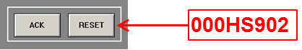
Figure 2-2: 000HS902 – Common Reset Switch

Important Monitoring Items

None

Interlocks

None

Control Sequences

None

Alarms

None

DCS Emergency Shutdown

None

Troubleshooting Guide

None

Trend Graphs Grouping

None

Annex 1: MS ENVIRONMENT DCS Graphics

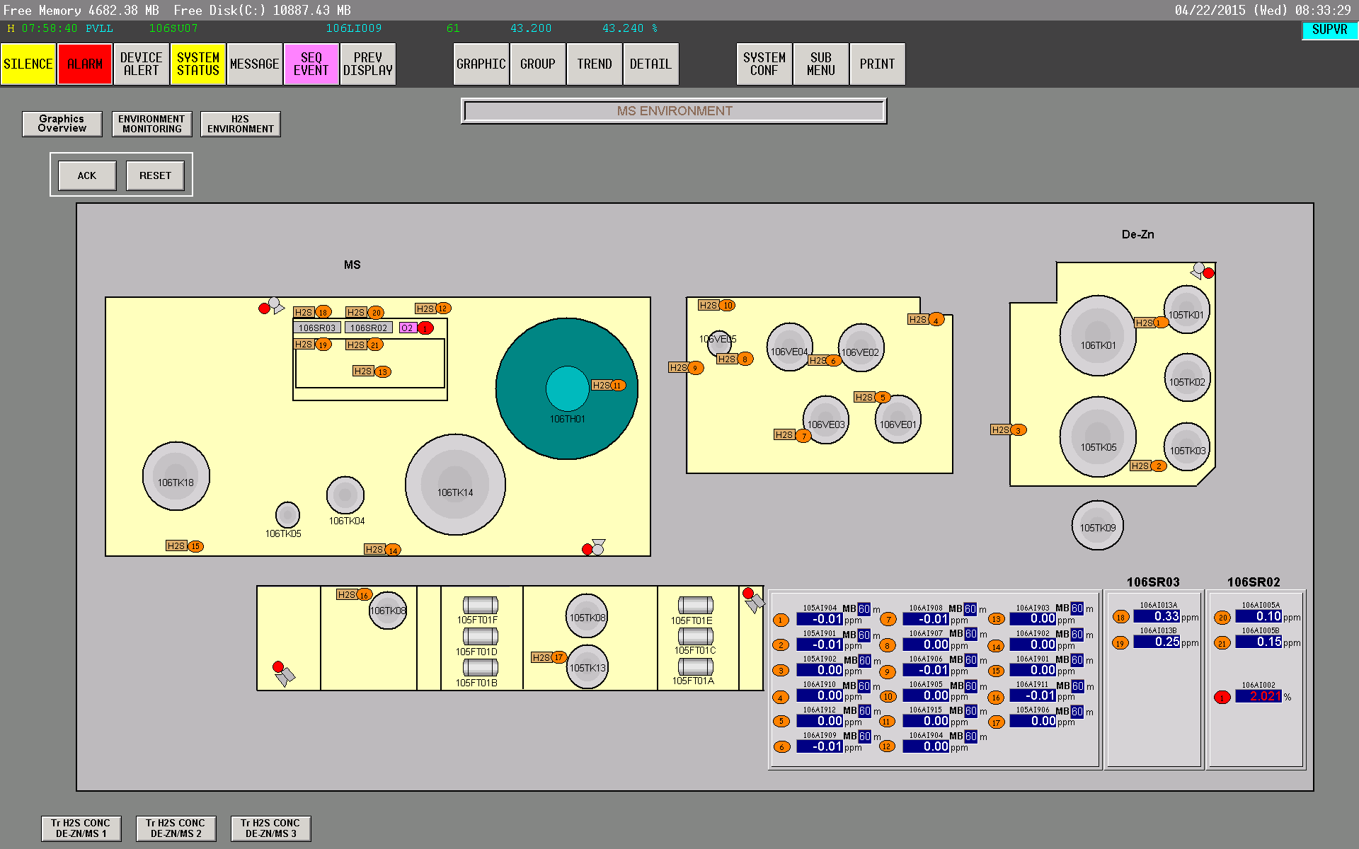
000HS901
000HS902

